RCPS Student Annual Updates
Parents,
Each year we ask that parents update student information in the Infinite Campus Parent Portal. These updates include forms that are signed yearly such as the Technology Acceptable Use Agreement and the Laptop Agreement for school issued devices. Students will not have access to the district network and district technology resources until the forms are completed electronically via the Infinite Campus Parent Portal.
To ensure we have updated information and your child has access to all digital resources please complete all Annual Student Updates in the Infinite Campus Parent Portal before the first day of school, August 1, 2022. Below is an instructional video as well as documents to help you navigate Parent Portal to access the documents.
Parent Portal Hints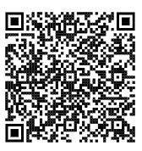
RCPS Parent Portal Site 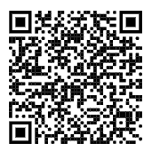
Need Parent Portal Support
Visit Alpha Academy Website: alpha.rockdaleschools.org
Email: jdyer@rockdale.k12.ga.us

